**Test cases on login page of facebook**

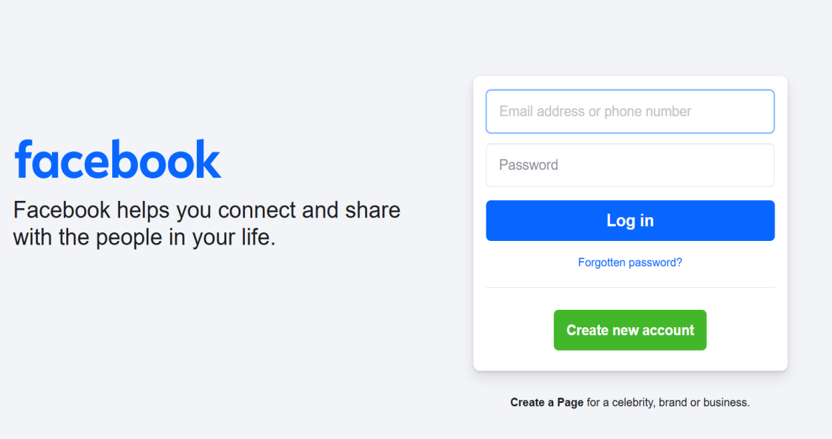

1. Verify that login page should get open when we hit the URL (<https://www.facebook.com/>) / Verify that the login screen should get open when we launch the application.
2. Verify that logo of the Facebook should be present.
3. Verify that the color, shape, size, font and position of the logo.
4. Verify that tagline is present or not.
5. Verify that font, color, position of the tagline.
6. Verify there should be no spell, grammar and punctuation error in Tagline.
7. Verify that all required labels, input fields, buttons links and texts should be present and clearly visible.
8. Verify that all buttons, text input fields and links should be properly aligned (There should not be any overlapping).
9. Verify the size of all buttons, links, texts and input fields.
10. Verify that the functionality should work in different browser (Cross browser testing).
11. Verify that tooltip is present or not.
12. Verify that placeholder is present or not.
13. Verify that the login page is responsive according to different screen sizes (Responsive Testing).
14. Verify that user is able to enter username.
15. Verify that user is able to enter password.
16. Verify that password should be masked/ encrypted.
17. Verify that the password should be visible on tap of “eye button” and again become encrypted on double tap.
18. Verify the minimum and maximum allowed character limit of username/ email.
19. Verify the minimum and maximum allowed character limit of password.
20. Verify the redirection of links present in footer section.
21. Verify that should not able be to login with blank username and password.
22. Verify that correct error message should be displayed when user enter blank email and password.
    1. Username and password cannot be blank
    2. Invalid email and password
    3. Email you entered is not connected to any account.
23. Verify that user should not be able to login with blank email and valid password.
    1. Invalid credentials
    2. Email and password combination is not correct
    3. Email is a mandatory field ✅
    4. Email id cannot be blank.
24. Verify that user should not be able to login with blank email and valid password. You have to check it for all permutation and combinations by using all possible inputs.
25. Verify that user should not be able to login with old password.
26. Verify that user should be able to login with new password.
27. Verify that user is able to set already used password as new password.
28. User should not be able to set username, email, phone number as password.
29. Verify that password should match expected criteria (one uppercase, one lowercase, one special character, eight digit long).
30. Verify that captcha, OTP, 2FA, OR MFA is enabled or not.